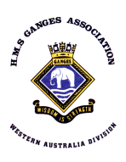

##### WA DIVISION HOIST MARCH 2018



# **G’day all,**

Here be the second Hoist of the year. Submissions of Items of interest for the Hoist are always welcome, but please be aware that as editor I reserve the right to edit submissions, if they are too large for the Hoist I will, as in the past, circulate items to members.

Division Almoner James Sharkey has been active since the AGM catching up with our members who do not or cannot attend regular meetings. I am pleased to report that most are well, although some are doing it a little tough. It should not simply be left to James alone, so, a heads up; we all have a membership list so please take the opportunity to contact oppos who you may not have seen or contacted for some time just to check on their welfare. If you have welfare concerns let James or I know so that these concerns can be followed up.

Alex & Liz McKinnon visited our favourite ex-wren Audrey Mantle recently. Alex reports, and the photos show, Audrey is in good health and spirits

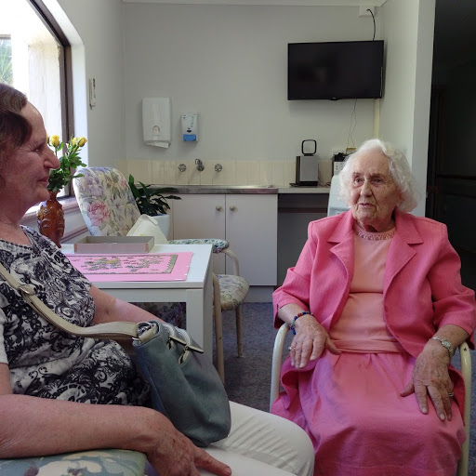

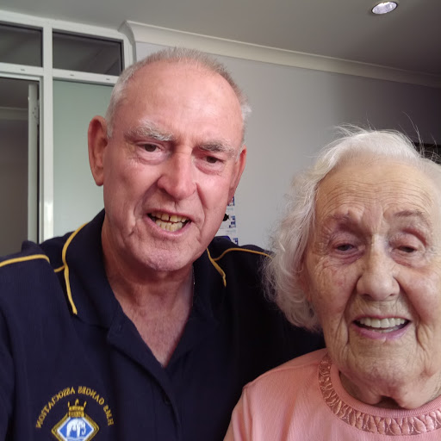

**Social Sausage Sizzle 25/02/18:**

The slightly modified arrangements for the day were successful. Our start was delayed until 1230 to allow Rockingham RNA to hold their meeting first. There was an excellent turnout with a combined total of between 30 and 40 (I did a head count earlier but people kept coming). Once again Gary did a great job as cook of the mess and there was an enticing assortment of salads and duff.

The new up-spirits rum arrangement was in place with both groups purchasing a bottle of Pusser’s from the RNC, these will remain under lock and key behind the bar. The RNA’s Knocker White ran two raffles (general & rum) with prizes spread fairly evenly between the groups. Our own Gary Foley won the rum raffle and was gracious enough to top up rum boson Alex’s flask and share his good fortune.

Gary had also invited a new contact, Brian Graves (73), along. Brian was promptly introduced to and sat next to Membership Secretary Peter Godfrey and is now our newest member. Welcome aboard Brian.

**Professional courtesy**

A woman and a baby were in the doctor's examining room, waiting for the doctor to come in for the baby's first exam. The doctor arrived, and examined the baby, checked his weight, and being a little concerned, asked if the baby was breast-fed or bottle-fed. 'Breast-fed,' the woman replied.

'Well, strip down to your waist,' the doctor ordered. She did. He pinched her nipples, pressed, kneaded, and rubbed both breasts for a while in a very professional and detailed examination. Motioning to her to get dressed, the doctor said, 'No wonder this baby is underweight. You don't have any milk.'

‘I know,' said the woman, 'I'm his Grandma, But I'm glad I came.’

**Sausage Sizzle at Tony Smiths:**

**The mast that Tony Smith built**

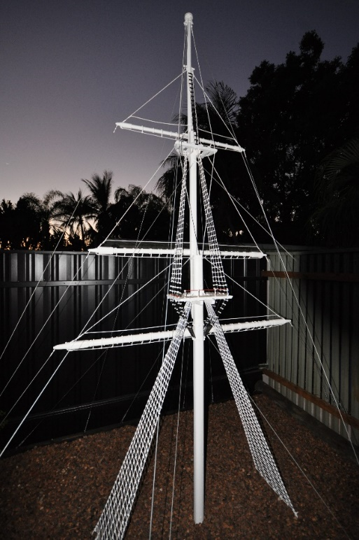

Thought you might like to see the treat you are in for at Tony & Jan’s place on the 15th March.

First erected in Karratha, then re-erected in Tony’s backyard in Warnbro three years ago. The mast, built to scale stands 11 feet tall and is lit up by red spotlights at night. Tony says he has lost count of the hours it took to build, rough sawn jarrah then carved by hand, the rigging was the tricky part.

A thing of beauty isn’t it.

**Division Gatherings for 2018**

|  |  |  |  |
| --- | --- | --- | --- |
| **Committee Meetings**  3rd Thursday of odd month  Commencing 1200  Fremantle Navy Club | **Division Meetings**  4th Thursday of odd month  Commencing 1200  Fremantle Navy Club | | **Social Sausage Sizzles**  4th Sunday of even month  Commencing 1200  Rockingham Navy Club |
| 15th March | 22nd March | | 22nd April |
| 17th May | 24th May | | 24th June |
| 19th July | 26th July | | 26th August |
| 20st September | 27th September | | 28th October |
| 15th November | 22nd November (AGM) | |  |
| Annual Black Tot Day Lunch  1200 Wednesday 1st August  at Fremantle Navy Club | | Christmas Lunch  1200 Wednesday 12th December  at Fremantle Navy Club | |

**Battleships by Robert Hore:**

I have just finished reading the above interesting book and I thought I would share some of the information contained within. The British Navy began to re-introduce the term battleship (derived from the term line-of-battle ship a style of sailing ship capable of taking its place in the line of battle which dominated warfare at sea from the 16th to 19th Century) around 1880 to mean a recognisable type of ship that was heavily armed and armoured. Broadly defined as a capital ship mounting guns of 255mm/10” calibre or more. The battleship took on many different shapes for the first 20 years of life as distinct species.

* During the Russian War 1854-6 (the Crimean War was in fact a campaign during this war) the French navy devised some armoured box-like ships with which they could approach the low-lying Russian fortifications. These craft which were little more than rafts, are generally considered to be the genesis of the modern battleship.
* The first breastwork monitor *Cerberus*, built in England 1867-8 for the Australian State of Victoria, was the first steamship to combine a central superstructure with fore and aft gun turrets, the first armoured warship built for Australia, and the first steamship to pass through the then newly completed Suez Canal. Her remains, she was scuttled as a breakwater, are those of the oldest surviving warship to have served in the Royal Australian Navy.

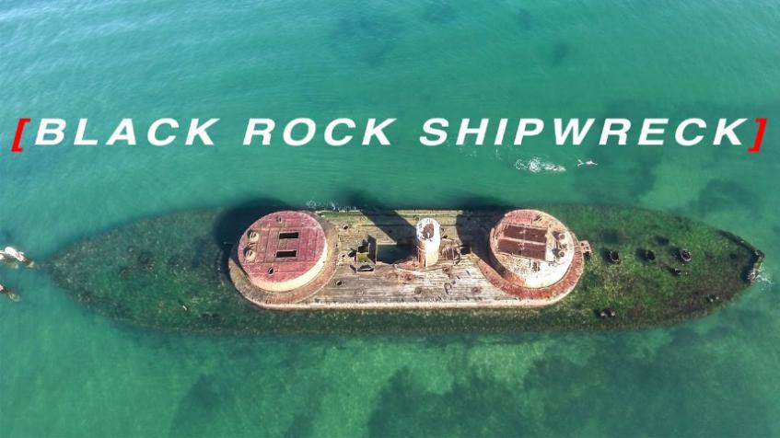

**HMVS Cerberus as a breakwater**

* Launched in 1909 the battlecruiser *Australia* became the first aircraft carrying ship of the Australian navy, using a platform built over her guns from which Sopwith fighters were launched as scouts and to attack Zeppelins. In WWI the Royal Navy led the world in naval aviation, and two ships, the battlecruiser *Furious* and the battleship *Eagle* were converted to aircraft carriers. In July 1918 Camel fighters from *Furious* successfully attacked Zeppelin sheds at Tondem in what must rank as the first carrier borne aircraft strike.
* The Battle of North Cape in December 1943 when the British Battleship *Duke of York* engaged and sunk the German battleship *Scharnhorst* was the last battleship-on-battleship action that took place between the Royal navy and German navy. (my old ships the cruiser *Belfast* was also there to help finish *Scharnhorst* with torpedoes)
* *Vanguard* was the last battleship to be built for the Royal Navy. She was launched in November 1944 but did not serve in WWII. *Vanguard* was re-fitted in 1947-8 and was then used as a training ship in Portsmouth where she became something of a fixture. She was sold for scrap in 1960 and scrapped at Faslane, this was the end of an era.

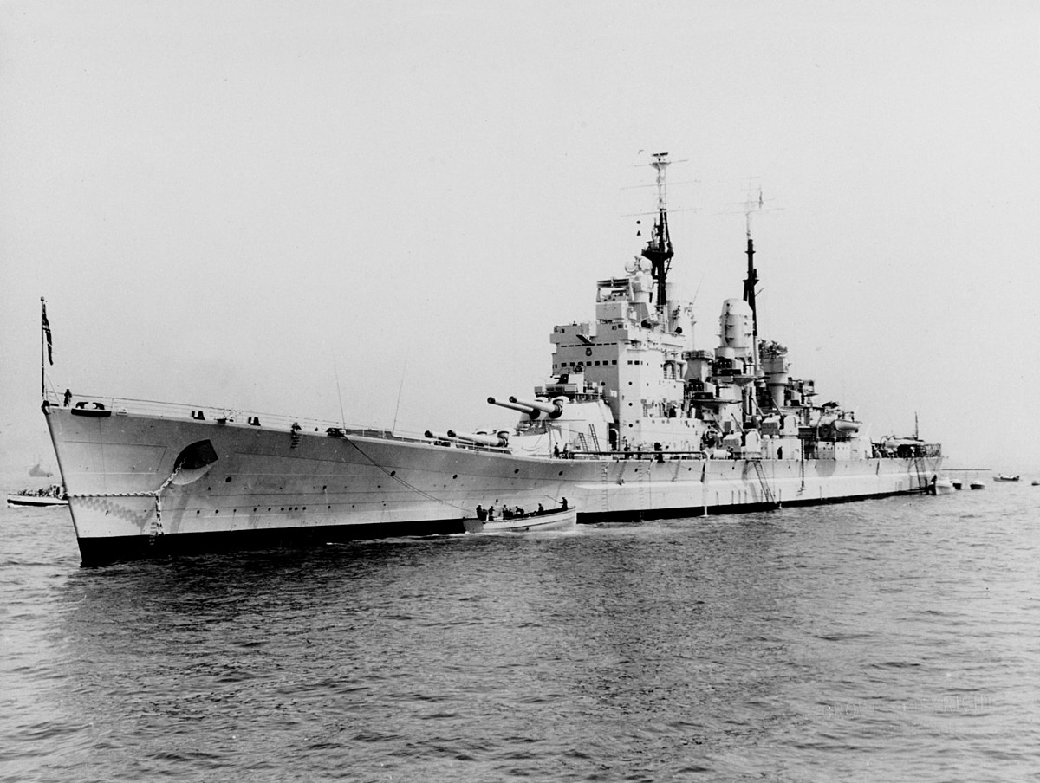

**HMS *Vanguard***

Many of us will remember the *Vanguard* as a depot ship in Pompey. An impressive vessel by any measure.

**RN Snippits:**

**HMS Queen Elizabeth’s first overseas port visit.**

The RN’S 65,000-tonne future flagship docked in Gibraltar for a routine logistics stop in February after having left her home in Portsmouth for helicopter trials.

These helicopter trials take place before the fixed wing F35 Lightning II trials later this year.

Gibraltar was seen as the perfect stop for HMS *Queen Elizabeth* as she will be conducting flying trials in the waters off the Iberian Peninsula.

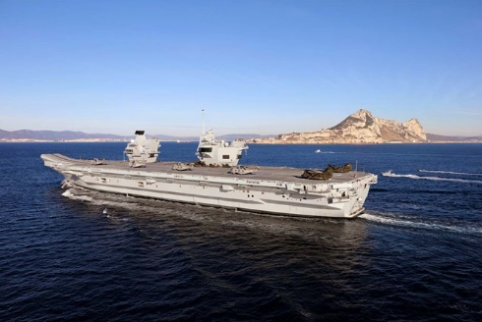

The carrier reached a major milestone in February when a Naval Air Squadron embarked in the ship for the first time, marking another first in the regeneration of the Royal Navy's carrier strike capability. Merlin Mk2 helicopters of Culdrose-based 820 Naval Air Squadron (NAS) have been working with the ship since she sailed from Rosyth for the first time in June last year. Leaving Gibraltar HMS *Queen Elizabeth* returned to sea to conduct helicopter trials with specially equipped Merlin and Chinook aircraft from the Aircraft Test and Evaluation Centre at MOD Boscombe Down. The data collected will be analysed to work out their operating parameters at sea, ahead of fixed wing flying trials with the F-35B Lightning II Joint Strike Fighter off the east coast of the United States in the summer.

HMS *Queen Elizabeth* has now arrived back in Portsmouth following the successful first of class rotary wing trials in the Atlantic. Speaking as the ship sailed into Portsmouth, HMS *Queen Elizabeth's* Commanding Officer, Captain Jerry Kyd said: "I am delighted with the rapid progress the ship is making toward becoming an operational aircraft carrier. The success of the rotary wing flying trials in the Atlantic with Merlin and Chinook is another important milestone on that journey. We are rapidly approaching our deployment to the United States in the summer when we will see the first F-35B Lightning aircraft land on *Queen Elizabeth's* deck. The ship is performing well and the marriage at sea of the Lightning and our carrier in a few months’ time will be a hugely symbolic event putting on notice that the UK is on the cusp of returning to fixed wing carrier operations at sea and a return to serious maritime power projection".

**2016 HMS Astute collision findings:**The senior naval officer in charge of teaching future submarine captains “took his eye off the ball”, leading his nuclear submarine to collide with a tanker, a court martial has heard. Cdr Justin Codd, 45, was sentenced to forfeiting a year of seniority after pleading guilty at Portsmouth naval base to negligently hazarding the £1.1bn submarine HMS *Ambush*. The Astute-class submarine was taken out of service for three months to undergo repairs costing £2.1m. Sentencing Cdr Codd, Judge Advocate Robert Hill said: “You have, save for this incident, an exemplary record. It was more in the nature of a momentary aberration than a careless attitude.” Captain John Atwill, prosecuting, said Cdr Codd was leading a group of students on the final day of the Perisher training course when the accident happened off Gibraltar on 20 July 2016. He explained that the students were practicing controlling the submarine at periscope depth and observing shipping movements. Captain Atwill said the failure happened because, despite the submarine having two periscopes, Codd failed to carry out his own observations and relied on the images provided by his students. He said the students had focused on a yacht called Katharsis and had not identified the risk posed by the tanker MV Andreas, which was “loitering” in the nearby area. Captain Atwill said: “Cdr Codd’s decision to focus on teaching, not safety, compounded the error carried out by the students.”

**HMS Ocean sold to Brazil:**The U.K. has sold Royal Navy flagship HMS *Ocean* to Brazil for £84 million as new aircraft carrier HMS *Queen Elizabeth* prepares to take over as leader of the fleet. The Brazilian Navy will pay for modifications to the ship, to be undertaken by UK firms Babcock and BAE Systems, and will then take possession of HMS *Ocean* in June.

HMS *Ocean* was one of three amphibious assault vessels to be successively designated flagship after the retirement of Britain’s most recent aircraft carrier in 2010, a trend defence experts said had left the Royal Navy weaker than ever before, since they couldn’t accommodate fixed-wing aircraft.

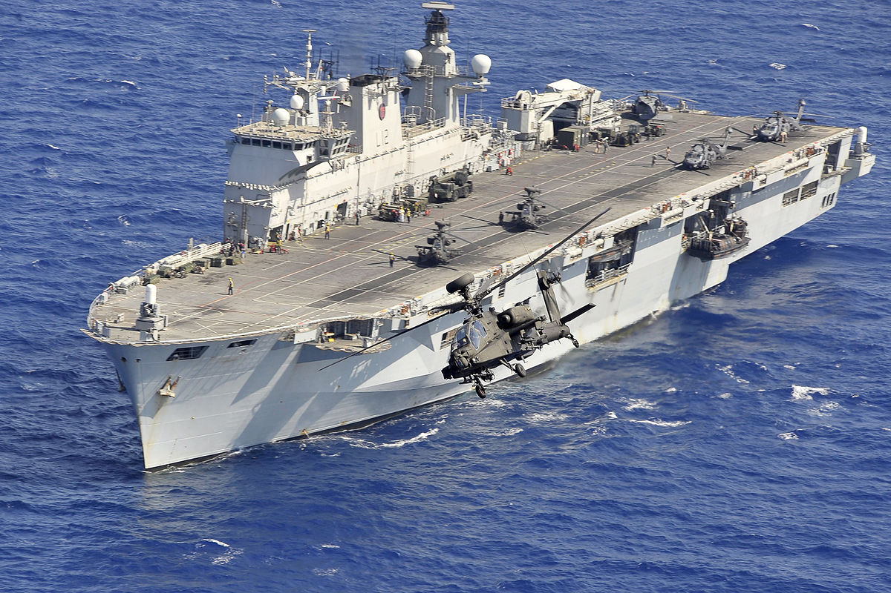

**Points to ponder!**

**As I get older I realize;**

* I talk to myself, because there are times I need expert advice.
* I consider "In Style" to be the clothes that still fit.
* I don't need anger management. I need people to stop pissing me off.
* My people skills are just fine. It's my tolerance for idiots that needs work.
* The biggest lie I tell myself is, "I don't need to write that down. I'll remember it."
* I thought growing old would take longer.
* I still haven't learned to act my age.
* Lately, I've noticed people my age are so much older than me.

**That’s all folks;**

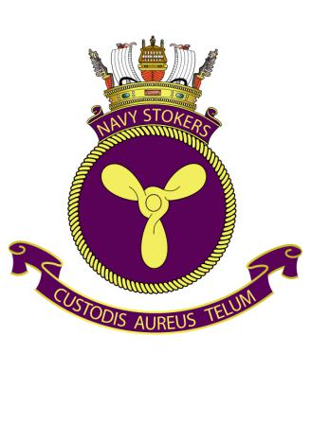

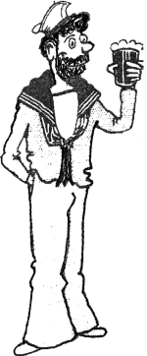

***Cheers aye – Ian***