

##### WA DIVISION HOIST MAY 2018



# **G’day all,**

This hoist will be a bit later than usual as I returned from the UK to find a lightning strike during a storm fried my modem and I am only just back on line, are well, thems the breaks!

Brian Thompson and I had a great trip, besides the Ganges Reunion we also managed to visit Shotley and Plymouth. We are booked in as the lamp swingers at our meeting of the 24th May so I will just include a couple of photos so as not to pre-empt the talk. However, the reunion itself was very well run and a credit to the Association, BZ to all involved.

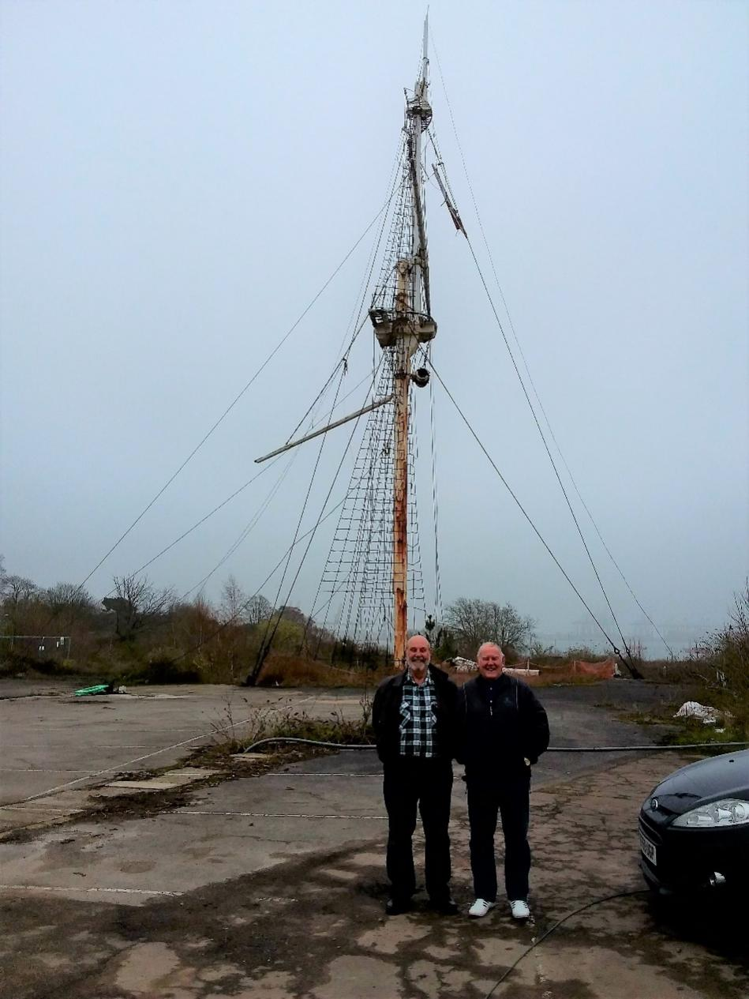

Brian and I visited the Ganges site. This was taken by the security guard who should have kicked us out after we wandered in but took a photo for us instead. If restoration work isn’t commenced soon it will all be on the deck. During our chat he did tell us the Nelson Hall is also to be refurbished.

As stokers, whilst in Plymouth we got the opportunity to visit HMS Raleigh, although she was closed for Easter the gatekeeper allowed us in for a photo after checking with his superior. No idea what’s under the canvas covers either side of the figurehead.

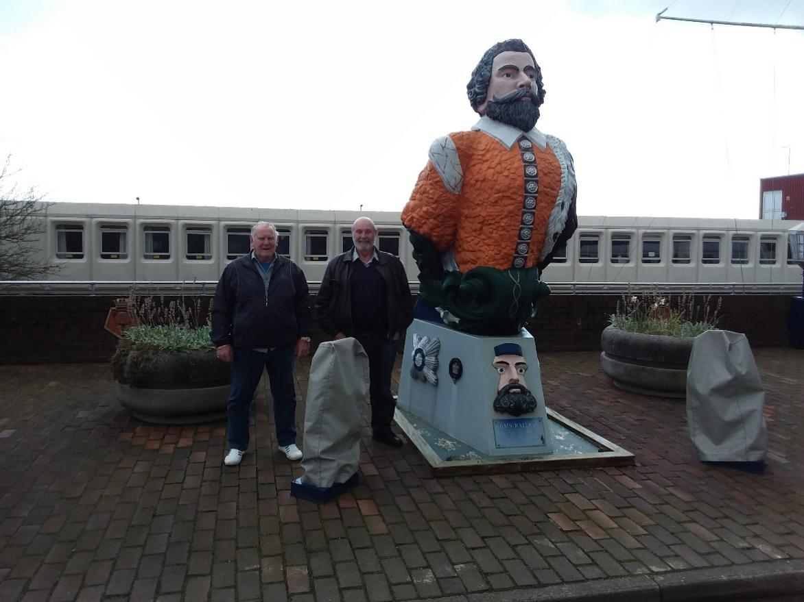

**Sausage Sizzle at Tony Smiths 15/03/18:**

A great time was had at Tony Smiths whilst checking out his mast. The photo says it all. For other than members Tony Smith is 3rd from left in back row with camera.

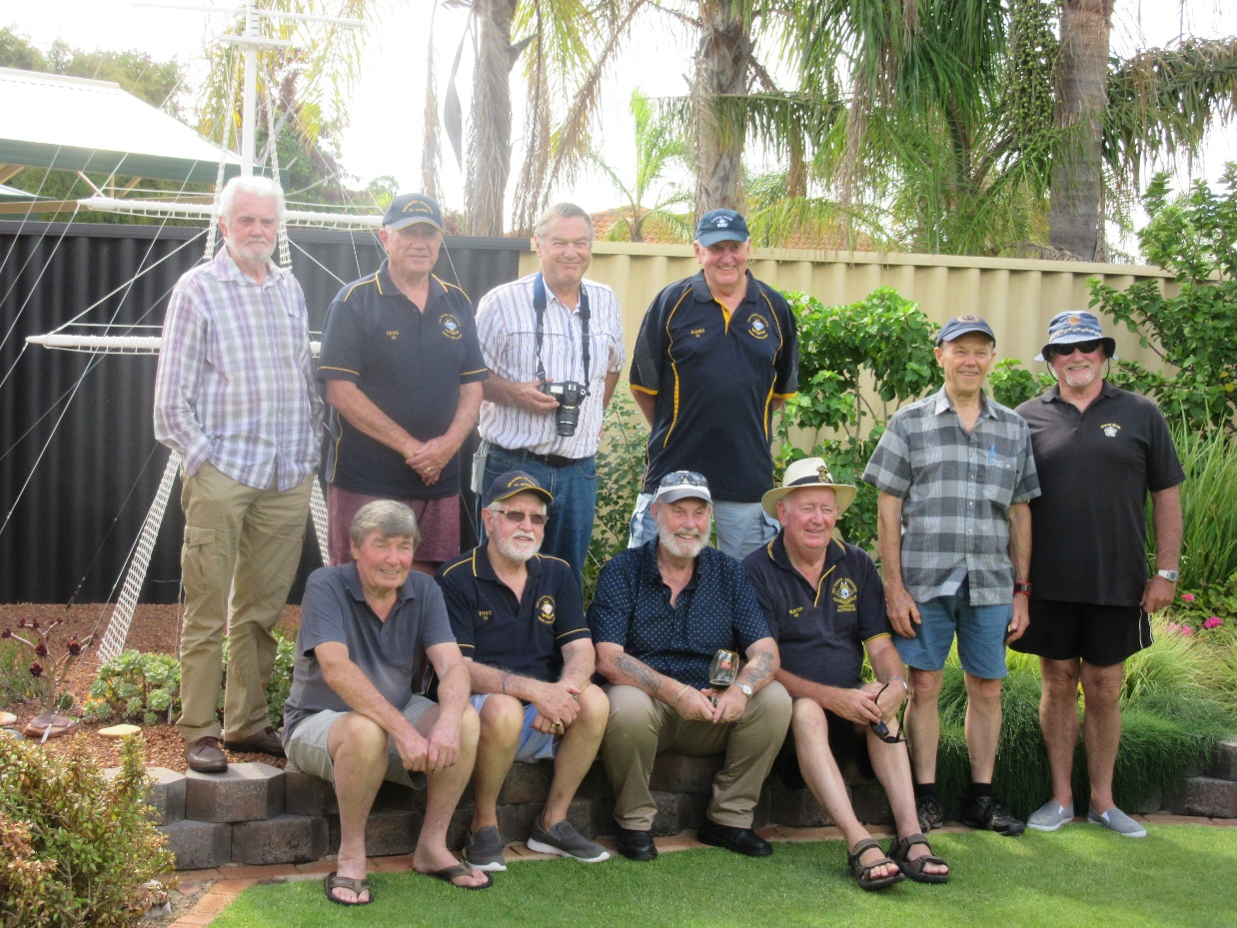

**Social Sausage Sizzle 22/04/18:**

I was in the air when this was taking place but the reports are it was another successful outing.

**Division Gatherings for 2018**

|  |  |  |  |  |
| --- | --- | --- | --- | --- |
| **Committee Meetings**  3rd Thursday of odd month  Commencing 1200  Fremantle Navy Club | **Division Meetings**  4th Thursday of odd month  Commencing 1200  Fremantle Navy Club | | **Social Sausage Sizzles**  4th Sunday of even month  Commencing 1200  Rockingham Navy Club | |
| 17th May | 24th May | | 24th June | RRNA |
| 19th July | 26th July | | 26th August | Ganges |
| 20st September | 27th September | | 28th October | RRNA |
| 15th November | 22nd November (AGM) | |  |  |
| Annual Black Tot Day Lunch  1200 Wednesday 1st August  at Fremantle Navy Club | | Christmas Lunch  1200 Wednesday 12th December  at Fremantle Navy Club | | |

**Ever wondered why ‘Tattoos’?**

The word *tattoo*, or *tattow* in the 18th century, is a loanword from the Samoan word *tatau*, meaning "to strike". The Oxford English Dictionary gives the etymology of tattoo as "In 18th c. tattaow, tattow. From Polynesian (Samoan, Tahitian, Tongan, etc.) tatau. In Marquesan, tatu." Before the importation of the Polynesian word, the practice of tattooing had been described in the West as painting, scarring, or staining.

This is not to be confused with the origins of the word for the military drumbeat or performance In this case, the English word *tattoo* is derived from the Dutch word *taptoe*.

The first written reference to the word *tattoo* (or *tatau*) appears in the journal of Joseph Banks (24 February 1743 – 19 June 1820), the naturalist aboard explorer Captain Cook’s ship the HMS Endeavour: "I shall now mention the way they mark themselves indelibly, each of them is so marked by their humour or disposition". The word *tattoo* was brought to Europe by Cook, when he returned in 1769 from his first voyage to Tahiti and New Zealand. In his narrative of the voyage, he refers to an operation called "tattaw".

A **tattoo** is a military performance of music or display of armed forces in general. The term comes from the early 17th century Dutch phrase *doe den tap toe* ("turn off the tap"), a signal sounded by drummers or trumpeters to instruct innkeepers near military garrisons to stop serving beer and for soldiers to return to their barracks, and is unrelated to the Tahitian origins of an ink tattoo.

The tattoo was originally a form of military music, but the practice has evolved into more elaborate shows involving theatrics and musical performances.

**RN Snippits:**

**The Royal Navy’s growth:**

Technically the RN is growing, just not any larger than it was four years ago. Statements made by the government explicitly claim that the Royal Navy is growing, but are those claims accurate? Ministers often spoke in Parliament last year of “a growing Royal Navy” but official figures appear to disagree with those claims. According to the UK Armed Forces Equipment and Formations document released by the Government detailing statistics on vessels, land equipment and aircraft of the armed forces. It states:  
“At 1 April 2017 there were 73 vessels in the UK Armed Forces: 64 vessels in the Royal Navy and nine in the Royal Fleet Auxiliary (RFA). This is a reduction of three vessels since 2016 following the withdrawal of three RFA vessels: two Small Fleet Tankers and one Forward Repair Ship (RFA Diligence).”

It gets a little muddier though as Guto Bebb, Parliamentary Under-Secretary of State for Defence, recently responded to a written question in Parliament, outlining the fleet size. “Based on the records held, the number of Royal Navy and Royal Fleet Auxiliary surface vessels in each of the last five years was:

|  |  |
| --- | --- |
| Year | Number of Vessels |
| 2013 | 78 |
| 2014 | 77 |
| 2015 | 75 |
| 2016 | 73 |
| 2017 | 72 |

This would appear to show a sharp decrease in hulls since 2013 and in the period when claims of “a  
growing Royal Navy” were shouted from the rooftops however Bebb added that current planning will see the number of hulls in the fleet increase: “On current planning assumptions the number of Royal Navy and Royal Fleet Auxiliary surface vessels in the next five years is:

|  |  |
| --- | --- |
| Year | Number of Vessels |
| 2018 & 2019 | 76 |
| 2020 to 2022 | 77 |

All this does however is highlight that the fleet size is only playing catch-up with where it was five years ago and even then, isn’t going to surpass the 2013 figure. Mark Lancaster, Minister of State at the Ministry of Defence, said: “For the first time in a generation, the Royal Navy is actually growing. It grew in manpower last year and will continue to grow over the next couple of years, and not just in manpower—the size of its surface fleet is also growing. The latest of the offshore patrol vessels arrived in Portsmouth only this weekend.”

According to the Defence Select Committee, the UK has a “woefully low” number of vessels. Chair of the committee Dr Julian Lewis advised earlier in the year that the Government risked leaving the country with fewer than 19 frigates and destroyers. “The United Kingdom will then lack the maritime strength to deal with the threats we face right now, let alone in the future. We are putting the MoD on notice that it must not let this happen.”

Additionally, Sir John Parker the author of an independent report on the National Shipbuilding Strategy, has indicated that the frigate fleet will fall below 13 frigates unless the Type 31 Frigate build starts soon,  
something that appears unlikely for a project described by a minister as still in “early pre-concept phase”  
with no design having yet been chosen.

Julian Lewis asked during a Defence Select Committee session on the National Shipbuilding Strategy: “So what you are saying—and this is a critical point—is that unless we start building the Type 31e frigates in parallel with the Type 26s, there is little chance of not reducing below our existing figure of 13 frigates all told. That, I must say, fits in with the projections I have seen and it follows from that, therefore, that we have to consider the best way of building two classes of frigates in parallel, rather than in succession.” Sir John Parker responded with one word: “Correct.”

In conclusion, the Royal Navy technically is growing if you can only remember as far back as a couple of years ago but this ignores that the numbers are playing catch up to where they were five years ago and aren’t going to exceed the 2013 fleet size. All the figures show is that the Royal Navy, overall, has shrunk in the last five years. **(**Source: SA’s Maritime News via UK Defence Journal)

**BAE Systems Showcasing Type 31e Frigate Design for the 1st Time**At DIMDEX 2018, the Doha International Maritime Defence Exhibition & Conference currently held in Doha, Qatar, BAE Systems is show-casing for the very first time the proposed design for the Type 31e frigate competition in the UK. BAE Systems has brought together its warship design and engineering capability and combat systems expertise with Cammell Laird, the commercial shipbuilder, in a Teaming Agreement to bid for the contract to deliver Type 31e, the UK’s adaptable general purpose frigate.

A key part of the Type 31e programme is configuring the new frigate and its Combat Management System to be attractive to potential international customers. BAE Systems’ design of this highly capable multi-mission warship demonstrates the flexibility of the ship to meet all warfare roles. Using a flexible mission bay that can be reconfigured at short notice it can perform constabulary, disaster relief, maritime interdiction, counter-piracy and joint taskforce operations.

With a proposed top speed in excess of 25 knots and a range of more than 7,500 miles, BAE Systems’  
design is equipped with some of the most modern and effective weapons systems available, and has been designed to operate in international waters, including the Gulf. It is capable of operating both independently for significant periods and as part of a task group, offering enormous value in bringing together allied maritime nations.  
The Type 31e design being proposed for the UK Royal Navy will also feature an enhanced BAE Systems  
combat system. Building on the pedigree of the systems installed across the UK Royal Navy’s fleet this  
combat system will add enhanced features through its open, secure, flexible and extensive architecture,  
ensuring it can be upgraded as new technology develops, adapting to ever-evolving threats.  
Angus Holt, BAE Systems’ Type 31e Programme Director, said: “We are proud to be displaying our Type 31e design at DIMDEX, the first opportunity for international audiences to see this highly capable ship. Our Type 31e design builds on the proven design and quality of our ships, including Type 45, Offshore Patrol Vessels and the Khareef vessels delivered to the Royal Navy of Oman. It also draws upon the invaluable experience of our Type 26 Global Combat Ship programme, giving us the confidence that we are able to offer a highly advanced ship that can be deployed for a variety of purposes around the world”.  
According to BAE Systems, the Type 31e will be a highly capable multi-mission warship, designed to deliver the full range of warfare from complex combat operations to maritime security and humanitarian assistance. The flexible mission bay means these ships can be adapted to support different missions within a short space of time. The ship will be equipped with some of the most modern and effective weapons systems available and will take full advantage of open systems architecture so it can easily be upgraded as new technology develops, ensuring it is adaptable to the evolving threats of tomorrow. It will be capable of operating independently for significant periods or as part of a task group. With the potential to accommodate sub-systems to meet individual country needs, the design offers enormous value in bringing together allied maritime nations. (source SA’s Marine News via Navy Recognition)

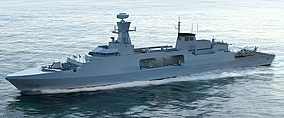  
Type 31e

**Point to ponder!**

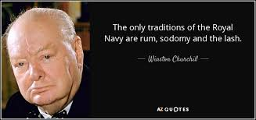

**That’s all folks;**

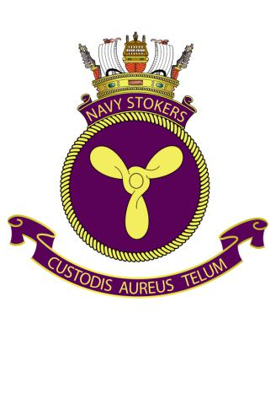

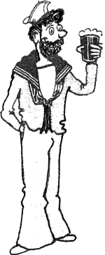

***Cheers aye – Ian***