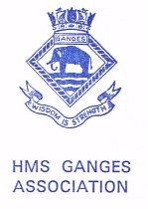
Victoria Australia
Chairman: David Lines. Secretary: Harry Harrison 36 Barretts Road Langwarrin South Vic 3911
Telephone Harry 03-9728-3200 Email:rodneyharrison@bigpond.com

MASTHEAD No. 192
Chairman David Lines Opened the meeting and welcomed all. Chairman welcomed Ron Benton good to see Ron after missing a couple of meetings also a welcome to Gary Taylor RNA and HMAS Sydney Association.
Apologies David and Jean Rees, John and Maureen Hannant, Owen and Carmel Dingle, Joe Deguara, Mary Stephens, Tom Clark and Jane. Harry and Winifred Harrison.
Sick List. David Rees has been in Beleura Hospital at the moment he is home. Our very best wishes to David.
Treasurers Report. Total monies in the Bendigo Bank account $5,282.48. Monies available for the Victorian Division $1,508.48. Reunion account $3,774.00. The account is now able to accept payments via the internet fund. To access the account for overview it is required that minutes of the meeting with a proposal for a named person or persons be presented to the bank. It was moved and seconded that Chairman David Lines and Treasurer Harry Harrison be nominated to access the Victorian Division HMS Ganges Association Bendigo Bank account via the internet. Carried unanimously.
Correspondence Bank Statements,SA. The Shotley Buzz #34. Emails from UK Chairman Shep Woolley emails and telephone calls from Jeff Lawrence in regard to his father Yeoman James Stewart Ganges 1946. Emails and telephone calls from various members in regard to reunion.
UK Association Communication with Chairman Shep Woolley, the UK reunion is being held at Gunton Hall, Lowestoft Suffolk, and is sold out. The Association is on a steady course forward which is good news. He asked that those with raffle tickets get them off to Dick Binch for the draw the first prize is a £1,000. Also if anyone is visiting UK and in the Portsmouth area check out Navy Days the Solent division will have the promotional trailer there.
General Business. 1) The reunion, please indicate if you are attending the reunion or any part thereof. The organising committee have discussed the following items :- a.) Goodies bag we need to investigate cost and suppliers. Also items for the bag.
b.)Name tags it was explained by Mike Bennett that at the submariners reunion that on the back of the tag was the reunion programme, on the front the reunion events the person is registered for also the number of the table the person is seated at for the formal dinner. It was agreed to adopt this procedure. Actioned by Albie Cunliffe. Albie is to be congratulated on his work on name tags, placemats and other printing and designs. BZ Albi for great work.
c.)Uckers boards it was decide to use the small boards. Rules Australian rules as in Fremantle they will be printed and distributed in good time.
d.) Official guest list this is being formulated. Chairman is in contact with the British High Commission for a representative to attend the dinner and the dedication service. Invitation cards are in the process of design.
e.)The dedication service is in advanced planning. We have to finalise what duties the cadets from TS Tingira will carry out. The service booklet has been completed and will be printed by courtesy of Mrs. Toni Munday the curator of the HMAS Cerberus. The Chaplain Clive Appleby is organising naval imaging unit to record the ceremony. Divisions and other Naval and Marine organisations have been contacted and informed standards will be paraded. A bugler is organised for the Last Post and Reveille.
d) Chairman David has been in contact with the representative of Pussers rum one of the items he offered to supply was a “scuttlebutt” this item was a bit of a mystery until it was discovered it is their name for a rum tub, of which we have a perfectly good one.
AOB 1) Ann Hillman informed the meeting that Lizzie Evans would be on holidays during April anyone wishing to meet up with her contact Ann.
2) Harry Kime asked if the Division was making a donation the FNMC for ANZAC day activities. It was agreed the sum of $100 be donated as was last year.
3) Members are reminded the next RNA lunch is a ST. Georges Day theme with a roast beef lunch Sunday 13th.April. The May lunch will be on the 18th. the third Sunday of the month. Members who wish to attend the Birthday lunch get their names down in good time as it is a very popular occasion.
Chairman Thanked Flo and Joan for an excellent lunch. Mark Kinder for attending the bar and Harry Kime for collecting the lunch monies.
There being no further business Chairman declared the meeting closed.
The next meeting is at Seven Bells *(1130hrs) April the 24. 2013*. At FNMC
Regards – Harry Harrison

Thought for the month:- Don’t tell friends about your indigestion: “How are you!” is a greeting, not a question. Arthur Guiterman.

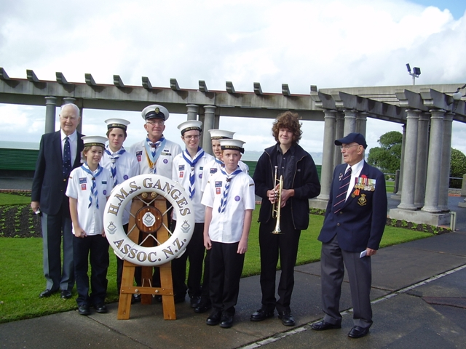
David Rees and Bill Gaillie with Sea Cadets at the Napier Reunion 2009
Since the meeting two respected and admirable men who have been stalwarts of the Australasian HMS Ganges Association Crost the Bar
Bill Gaillie and David Rees.

William Edward Gaillie. 6th. January 1919-28th. March 2014

Bill joined Ganges 2nd. September, 1935 he joined the Renown as an AB in 1939 and left as a PO gunners mate in 1942. 14th. October, 1943 he was commissioned as a Gunner. He returned to Ganges as second DO for Hawke Division April 1950 to August 1952. He retired from the RN in 1958. Many will know Bill from reunions he attended. Bill was the oldest surviving member for Australasia for his 90th.birthday he did a tandem parachute jump. Those who were in Napier for the reunion and probably many others tasted Bill and his wife Anne’s skills in distilling with his very generous samples of his rum. Bill will be missed by all. We extend our condolences to his wife Anne and family. William Edward Gaillie.

David Lawrence Rees 1st September 1929-March 31st. 2014
David joined Ganges 30th. October 1945 -1946 After Ganges he took passage on the Formidable to Hong Kong and joined the Belfast. Returning to the UK he was drafted to HMS Dryad for RP training. He joined the Starling in the Dartmouth squadron. With the outbreak of the Korean War he was drafted to HMS Alacrity and took passage on the Ocean to join it. After the Korean War he was in the Malaysian conflict. He then served on the Boxer a converted tank landing craft which was a radar training ship. He then joined HMS Vanguard in Gibraltar. His next draft was Staff Coxswain to C in C Portsmouth. Then the Albion which was engaged in the Suez crisis. Then as instructor in pilotage at the Command Seamanship school at Flathouse Portsmouth. After completing a radar instructor’s course he was drafted to Excellent to do a commissioned gunners course. He qualified as Sub lieutenant (SD) gunnery. His first commission was aboard the newly commissioned Londonderry. He was designated as Diving officer so did a diving and explosive course. Onboard the ‘Derry he instituted that Senior Ratings could entertain guests from ashore quite a novel idea at the time. He then returned to Ganges as second DO of Hawke division for two years. His last ship was the Barossa in the Far East Fleet. The Barossa was engaged in the Indonesian confrontation. He then served on HMS Excellent on the Commanders staff until his retirement in 1968. He Jean and family then immigrated to Australia on a short service commission in the RAN. He resigned from the RN in 1971. In civvy street he worked for insurance companies and as in his naval career he made a success of it. David was an early member of the HMS Ganges Association and a founder of the Victorian Division. He worked tirelessly to advance the association and was at the forefront of the Australasian reunions. David was a devoted family man and the closeness of his family is testament to his and his wife Jeans commitment to their children, grand children and great grandchildren. He also worked on many projects some he set up to help those less fortunate in society. We pay our respect to one of natures gentlemen and offer our condolences to his wife Jean and family.
Vale David Lawrence Rees

